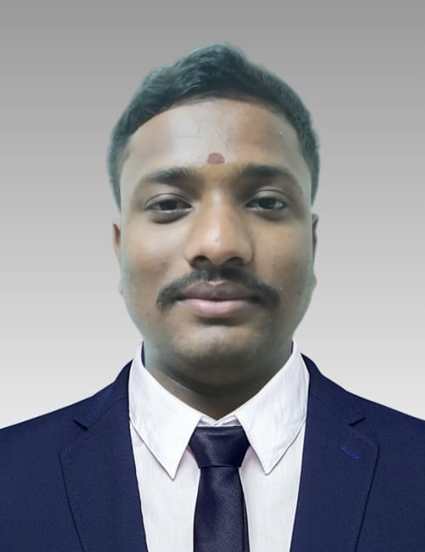

**VANKA DHANARAJU**

**E-MAIL:- dhanaraju2946@gmail.com**

**MOBILE: - 9963442011**

**Career Objective**

To Work in healthy, innovative and challenging environment extracting the best out of me, which is conductive to learn and grow at professional as well as personal level there by directing my future endeavours as an asset to the organization.

**Education Qualification**

|  |  |  |  |  |
| --- | --- | --- | --- | --- |
| **Qualification** | **University/Board** | **Institution** | **Marks %** | **Year of Passing** |
| PGDCA | IISDT,  Madhya Pradesh | Indian Institute of Skill Development Training | 75% | 2023 |
| M.Com | Dr.B.R.Ambedkar Open University, Hyderabad | Dr.V.S.KRISHNA Govt Degree College(A)  Study Canter | 65% | 2022 |
| B.Com | Andhra University, AP | Dr.V.S.KRISHNA Govt Degree College(A) | 79% | 2019 |
| Intermediate Vocational (B.F.S) | Board of Intermediate., AP | Govt. Vocational Jr College | 78% | 2016 |
| SSC | Board of Secondary Education., AP | C.B.M High School | 4.8% | 2014 |

**Technical Skills**

* MS Office & Excel
* Typing
* Tally basic

Extra- Curricular Activates

* NSS, College & University Award 2018 – 2019
* 9 Times Blood Donation personally
* Indian Red Cross Society
* Participated in Seminars at college level

Experience

* Working as a Computer lab Asst at Dr.V.S. KRISHNA Govt Degree & PG College (A), Visakhapatnam. Since 2 Years
* Working as a Guest Faculty (Commerce) at Dr.V.S. KRISHNA Govt Degree & PG College (A), Visakhapatnam. Since 1 Years

**Personal Details**

Name : Vanka. Dhanaraju

Father Name : Vanka .Guruvoji

Date of Birth : 14-08-1999

Gender : Male

Caste : BC-A (Vodabalaji)

Marital Status : Unmarried

Nationality : Indian

Languages Knows : Telugu, English

Religion : Hindu

Hobbies : Yoga & Running, Reading Stories, Music.

Strengths : Belief in hard work, Ability to learn new things, Self

Confidence, Positive Attitude, Good Communication Skills.

Address : D.No:-20-36-20, Paindoorapeta (Urban) Visakhapatnam,

530001.

**Declaration**

I hereby declare that all the information mentioned above is true to the best of my knowledge.

Date:

Place: Visakhapatnam Signature: